Design Planning

# UML Diagrams

## Structure Diagrams

* Class Diagram - depicts the static structure of a system by showing system’s classes, their methods and attributes. Class diagrams also help us identify relationship between different classes or objects.

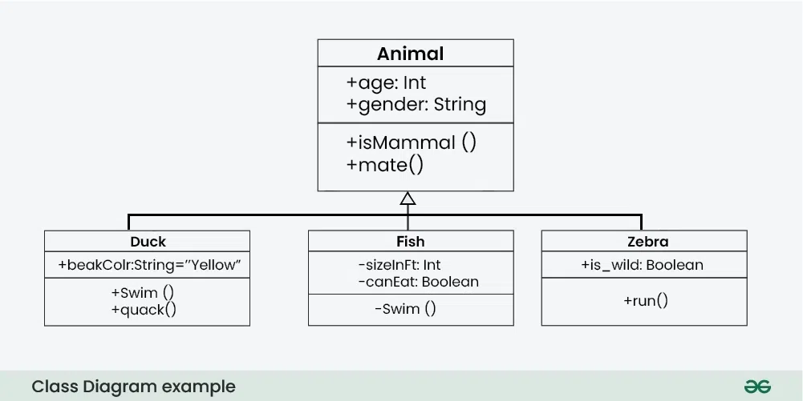

* Use Case Diagram - depicts the functionality of a system or a part of a system. They are widely used to illustrate the functional requirements of the system and its interaction with external agents(actors).

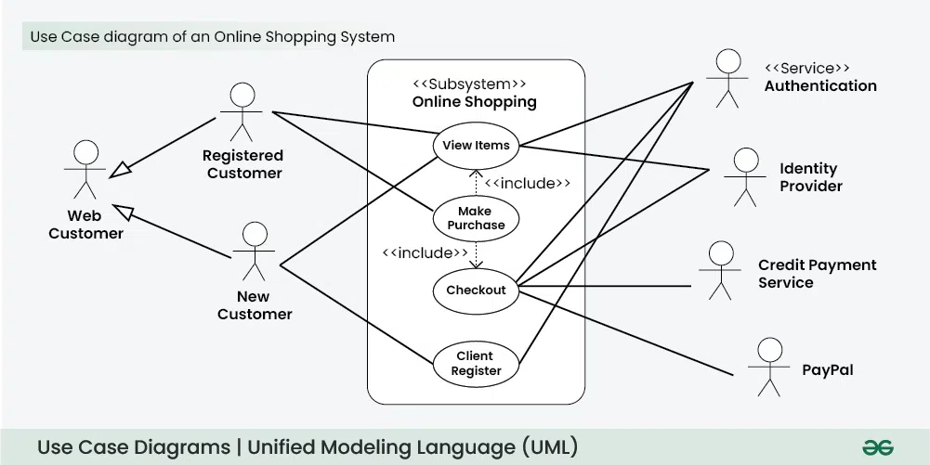

# Other Diagrams

## Structure Diagrams

* Salt (GUI Designer) - a subproject included in PlantUML to design graphical interfaces.

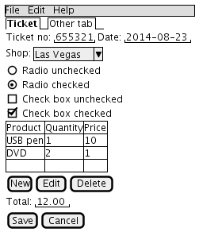

* Entity-Relationship Diagram - a visual representation that shows how different entities relate to each other within a system, often a database or a business process.

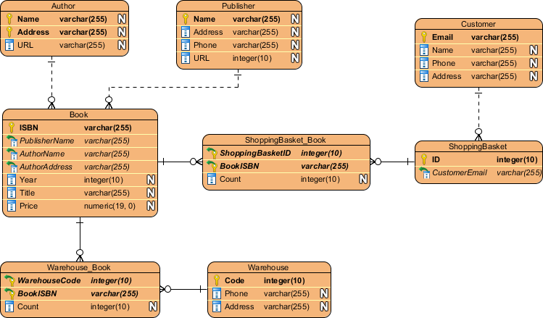

## Project Management Diagrams

* Work Breakdown Structure Diagram (WBS) - a hierarchical decomposition of a project into smaller, more manageable components or tasks. It's a visual representation that breaks down the entire project scope into a clear, organized structure, making it easier for project teams to plan, schedule, and track progress.

